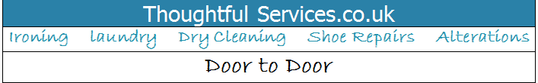
Name................................................. Telephone …………………………………………

Address............................................... Day to be ready.................................
Email Address....................................... Is it for delivery?...............................
Please complete the RELEVANT tables below. Thank you.
DRY CLEANING  Description | Amount
WASHED AND IRONED | Amount
Men’s shirt
Blouse
T-shirt/ Top
Jumper /Cardigan
Jacket
Trouser/Short
Dress
Pillowcase
Single sheet
Double king size sheet
Super king size sheet
Duvet cover single
Duvet cover double
Duvet cover king size
Duvet cover super king
Tablecloth
Miscellaneous
Total
IRON ONLY | Amount
Men’s shirt
Blouse
T-shirt/Top
Jumper/Cardigan
Jacket
Trouser/Short
Dress
Pillowcase
Single sheet
Double king size sheet
Super king size sheet
Duvet cover single
Duvet cover double
Duvet cover king size
Duvet cover super king
Tablecloth
Miscellaneous
TOTAL
TOTAL
REPAIRS /ALTERATIONS (please give detail of what is required)
TOTAL
List No |  | Total Items
0208 407 1078. Please visit our website for our full terms and conditions www.thoughtfulservices.co.ukTo pay by bank transfer please use your address as reference and pay on the day of delivery. Thoughtful services ltd, sort code 09-01-28, a/c no 55197949

